**EXPLORATORY DATA ANALYSIS - PANDAS**

AGE

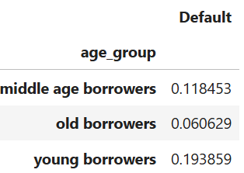

AGE:

1. *Lenders often perceive younger borrowers (21-30) as higher risk due to limited credit history,*
2. *while older borrowers (51+) may face stricter eligibility requirements and potentially higher interest rates due to nearing retirement.*
3. *Mid-age borrowers (31-50) generally have more established credit and income, making them more attractive to lenders.*

INTEREST RATE

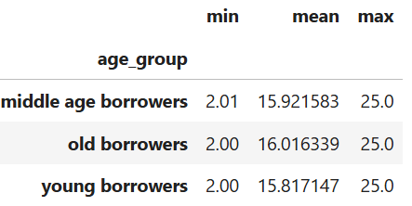

INTEREST RATE:

1. *For defaulters we can see that the interest rate is higher than global average of interest rates which can be one of the reasons behind defaulting.*
2. *For non-defaulters we can see relatively lower interest rates. This can be one of the reasons that they didn’t default*

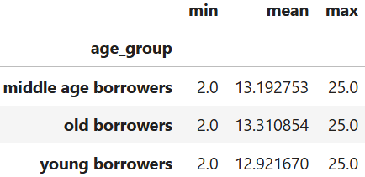

INCOME

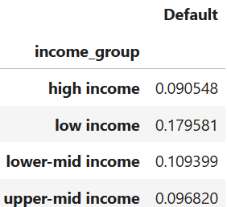

INTEREST RATE:

1. *Most of the defaulters are from low income group.*

CREDIT SCORE vs MARITAL STATUS vs DEFAULTERS

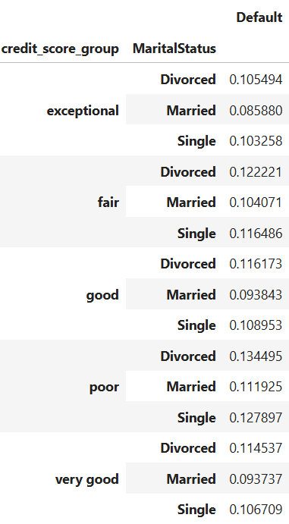

CREDIT SCORE vs MARITAL STATUS vs DEFAULTERS

1. *for poor credit score people who are either divorced or single have high default rate, same in case of exceptional as well.*
2. *so married people tend to have settled in life and pay their loans on time and thus maintain the sredit score*

EDUCATION

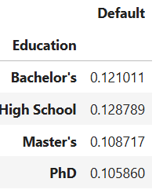

EDUCATION

1. *Higher the Education Degree lower the default rate, which is expected.*

EMPLOYMENT TYPE

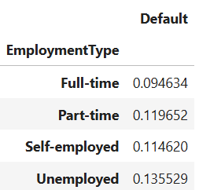

EMPLOYMENT TYPE

1. *Unemployed people have the highest default rate.*

LOAN PURPOSE

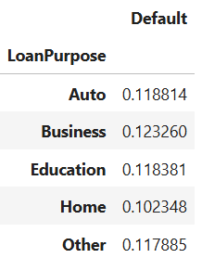

LOAN PURPOSE

1. *People who take loan for the purpose of BUSINESS, tend to DEFAULT more (mostly incase the business doesn’t work)*

DTI RATIO

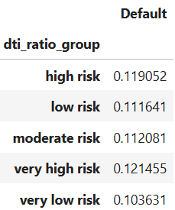

DTI RATIO

1. *here we can see that DTI ratio with ratio greater than 0.5 or 50% which indicates very high risk, have mostly defaulters*

FEATURE ENGINEERED COLUMNS:

LOAN to INCOME RATIO

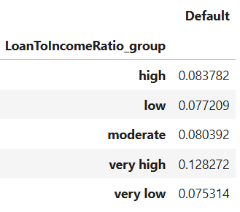

LOAN to INCOME RATIO

1. *Very high bin indicates that loan amount taken is more than the income, and thus most defaulters are present there.*

EMPLOYMENT LENGTH

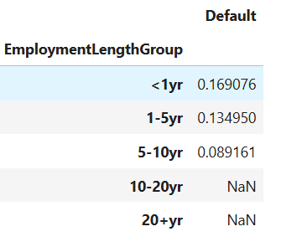

EMPLOYMENT LENGTH

1. *People with <1year of employment tend to DEFAULT more.*

MONTHLY PAYMENT

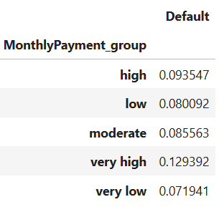

MONTHLY PAYMENT

1. Higher monthly payment burden leading to more DEFAULTERS.

CORRELATION

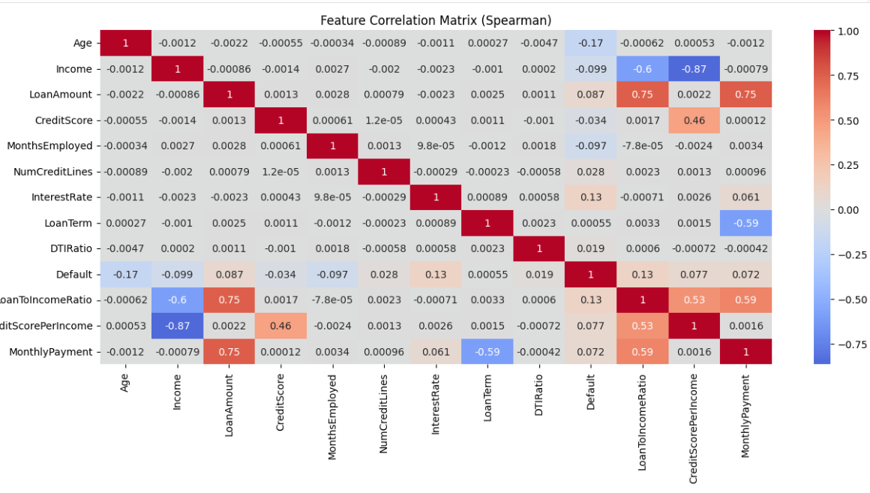

CORRELATION

1. Age, income, loan amount and credit score are correlated.

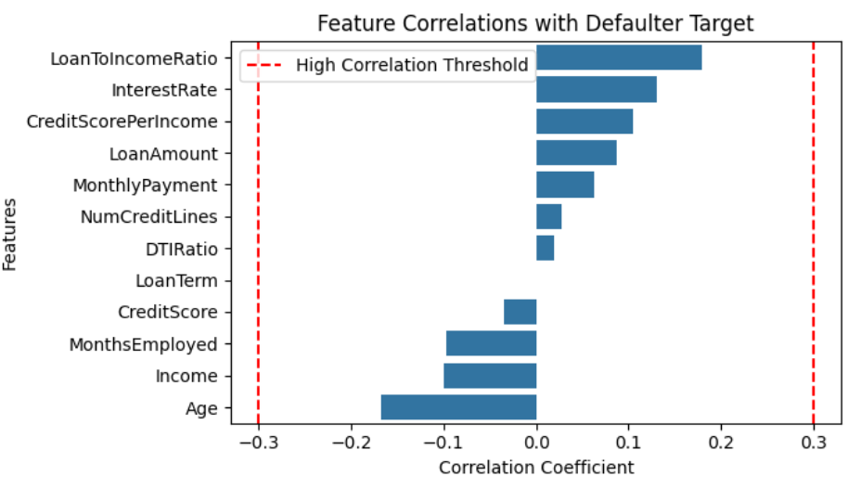

FEATURE CORRELATION with DEFAULTER

1. Loan to income ratio, interest rate, age and income play a very significant role.